EXPERIMENT-12 Z-SCOORE NORMALIZATION:
AIM:
To write the program for Z-scoore normalization using R-tool.
PROGRAM:
diabetest1&lt;-read_excel(&quot;C:/Users/M.Geetha/Downloads/NARA.xlsx&quot;)
A&lt;-c(diabetest1$Age)
Mean&lt;-mean(A)
Std&lt;-sd(A)
Zscore&lt;-(A-Mean)/Std
Zscore
OUTPUT:
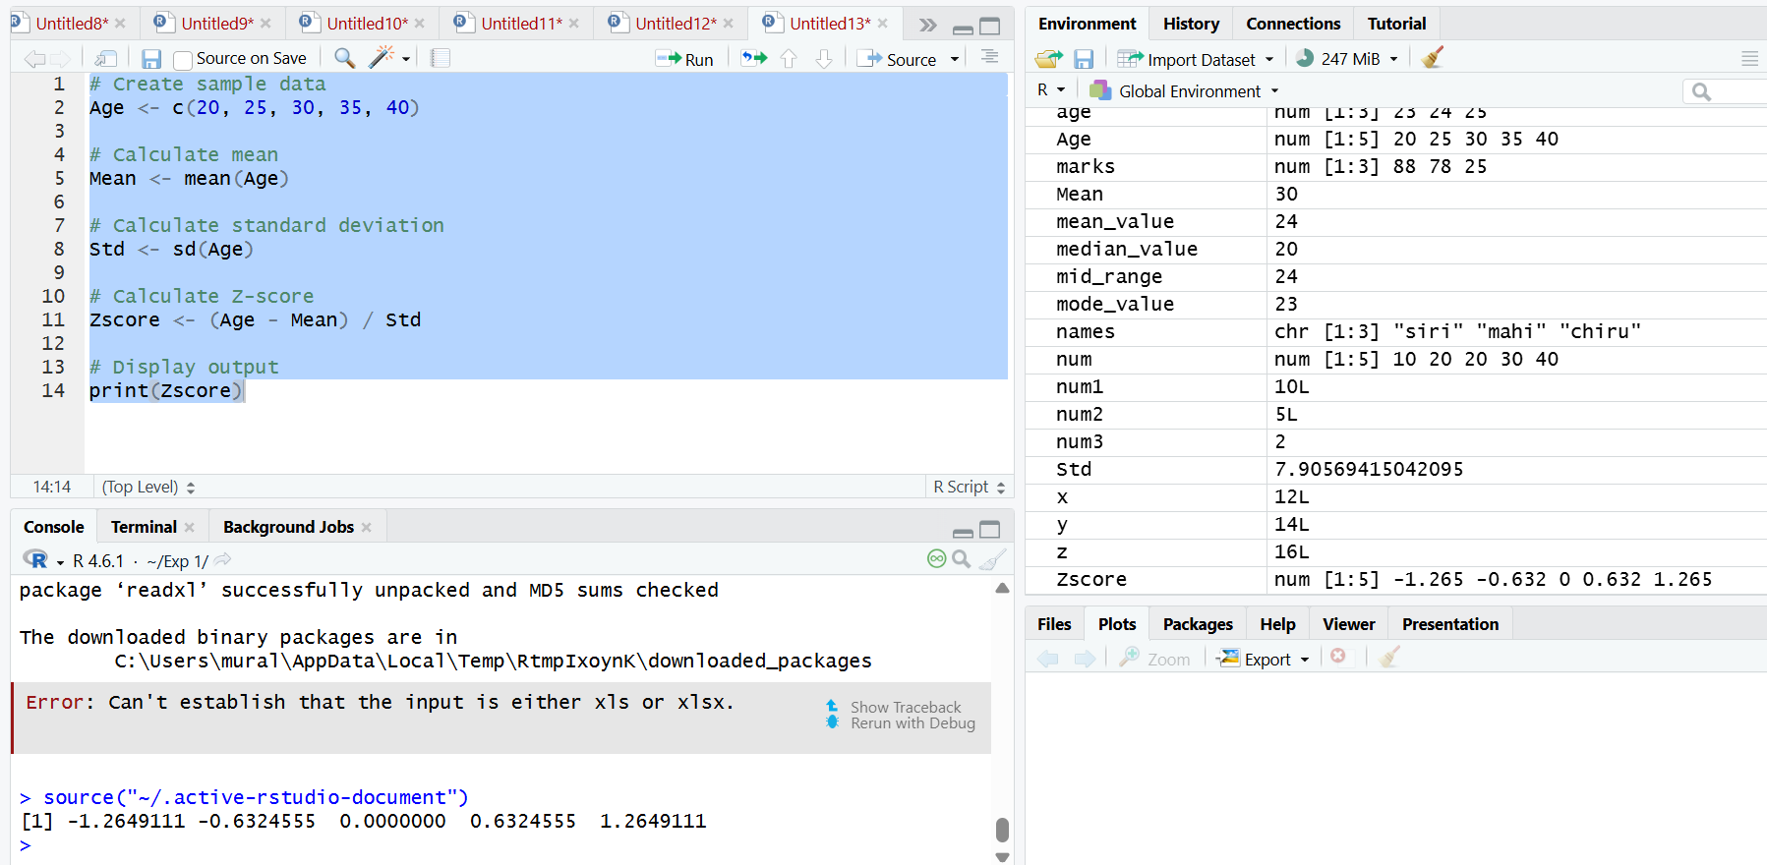

RESULT:
Thus, the Z-score normalization using R tool was executed successfully.

